GSM/3G Gate Controller
Quick Guide

Model: G202 Version: 1.00

SMS Command Settings

Read the cautions as below:
About the SMS commands in the charts below is presented as examples, please use it according to your real situation. Read the cautions as below:
- All the red letters in the SMS command should be in CAPS.
- Add your country code before the phone number, such as”0044” in UK.
- Do not leave any space in the SMS command.
- Sending SMS command may have some cost which charged by your local mobile operator. But dial to open the door is free of charge.

Function | SMS Command | Meaning
Change password | 1234#PWDnewpassword#PWDnewpassword#  (1234#PWD6666#PWD6666#) | Default is 1234 (4 characters)
Add new user | 1234#TEL0044777777#002# | Add phone number to 2nd position of the user list. From 001 – 200. The “001” is the Admin.
Check user’s position | 1234#TEL005? | Check the 5th User’s Phone Number Total 200 users: 001 - 200
Delete the user | 1234#TEL#005# | Delete the 5th user in the user list.
Set the  authorization | 1234#AA# | Anyone could open the door by SMS or CALL
 | 1234#AU# | Only authorized users could open the door
Set the relay time | 1234#GOT10# | The relay will close after 5 s.Relay time:00 - 19.Default time is 0.5 seconds(500 ms),the relay closed time is twice as the number you set
Operate the door  by SMS | 1234#ON# | Open the door by SMS
 | 1234#OFF# | Close the door by SMS
Check GSM signal quality | 1234#CSQ? | Check the GSM signal quality

Disable the Notification Message of the Relay Status?

1234#R#
-
1234#N#
-

Meaning: When the relay is ON/OFF, the device will not send notification message.

How to Reset the Device?

If you want to reset the G202 to factory default, then please send 1234#RESET# （The unit will reply a message with Reset Success! Please Reboot your Device ) or When the G202 works normally, you can press and hold the RESET button for several seconds until the Run Led is always ON, and then after 5 seconds ,it will reset the G202 to factory default.
NOTICE: The RESET setting will reset all data as default.
Introduction & Parameter
G202 could be well integrated with most of the electronic locks, gate motors, gate operators.The users could dial the SIM card number to open the door, and no phone charges, no distance limits, no keyfobs, more convenient and friendly than any other solutions in current market.

GSM/3G Frequency | GSM: Quad-band 850/900/1800/1900MHz 3G WCDMA : 900/2100 MHz UMTS  3G CDMA2000: 850/1900 MHz UMTS  3G: 850/2100 MHz UMTS.
DC Power | DC 9V – 30V /1A
Power consumption | Max. 50mA/Average 25mA
SIM Card | Nano type, 3V
Antenna | 50 Ω SMA
Relay Specification | 3A/250V AC | 20A/14V DC
Relay Type | NO/NC
Relay Time | Max. 0s - 9.5 s
Users | 200
Wired Switch | Supports
Operating Temp | - 10℃ ～ + 60℃
Relative Humidity | 10％ ～ 90％( RH)
Dimension | 96.5×50×31.5mm
Net Weight | 88g
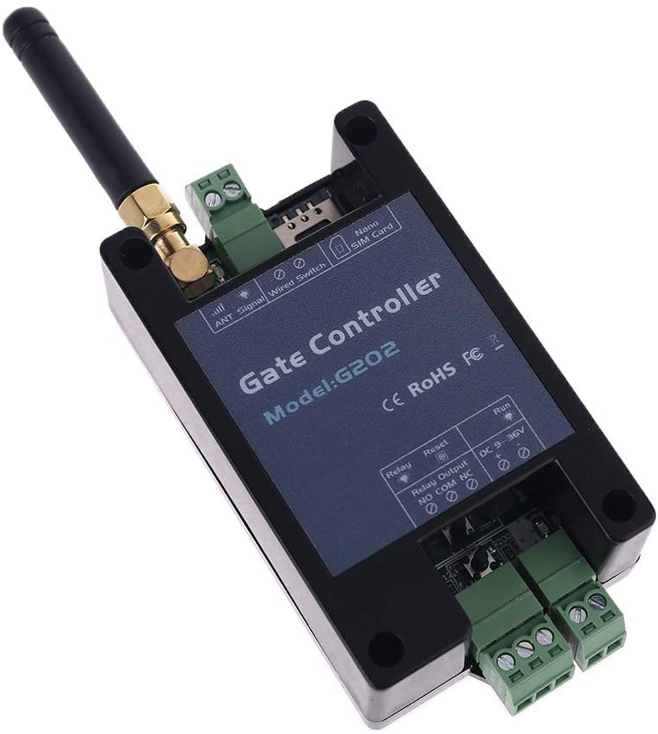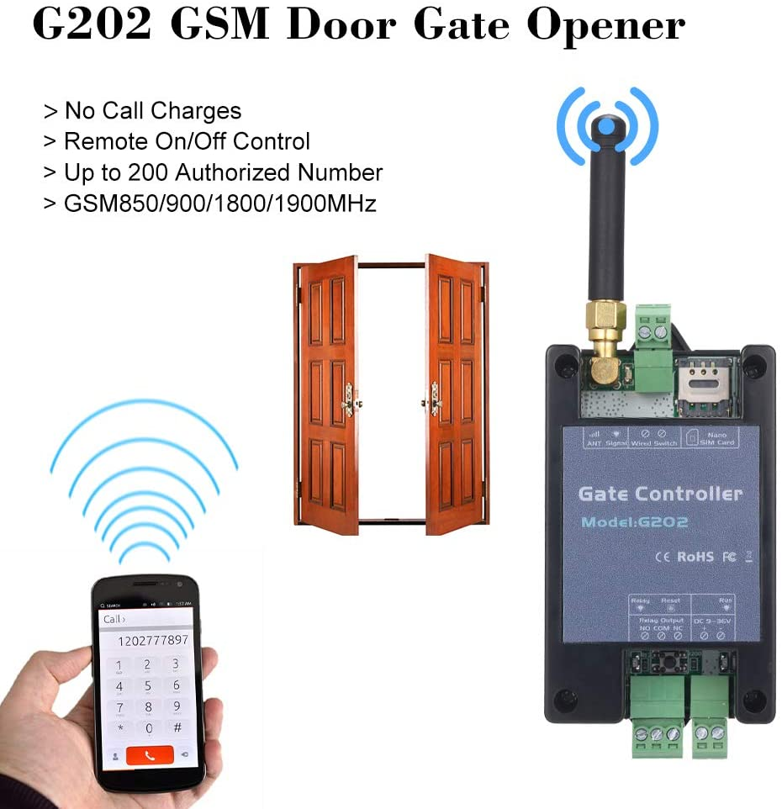

Package
1).The Device *1pcs
2) .The Antenna *1 p c s
3).The Wiring Terminal * 3pcs
4).The Quick Guide Brochure * 1pcs

Notice:The package is WITHOUT Power Adapter and Push Button. The default device only supports GSM.

